**Roll no:- 88**

**Name:- PATIL PALLAVI KALYANSING.**

**Assignment no:- 1.1**

**Assignment no:- Develop programs to understand the control structures of python**

**(Conditional statement)**

* If Statement :-

a = int(input("Enter 1st number: "))  
 b = int(input("Enter 2nd number: "))  
  
 if (a > b):  
 print(a , " is greater than ", b)

* Output :-

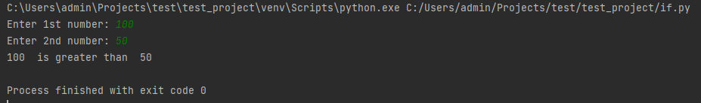

* If…else statement :-

a = int(input("Enter 1st number: "))  
 b = int(input("Enter 2nd number: "))

if (a > b):  
 print(a ," is greater than ", b)  
 else:  
 print(a, " is NOT greater than ", b)

* Output :-

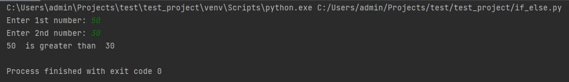

* elif statement :-

a = int(input("Enter 1st number: "))  
 b = int(input("Enter 2nd number: "))  
  
 if (a > b):  
 print(a ," is greater than ", b)

elif (a < b):  
 print(a, " is less than ", b)  
 else:  
 print(" Both are equal ")

* Output :-

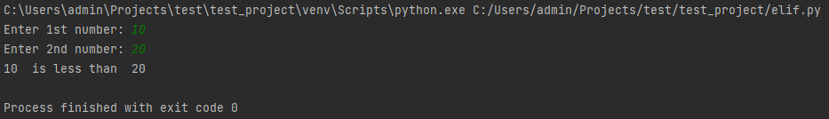

* Ladder statement :-

a=int(input("Enter 1st number:"))  
 if a >= 90:  
 print("Outstanding")  
 elif a >= 80:  
 print("Excellent")  
 elif a >= 70:  
 print("Good")  
 elif a>= 50:  
 print("Poor")  
 elif a>= 24:  
 print("Pass")  
 else:  
 print("Fail")

* Output :-

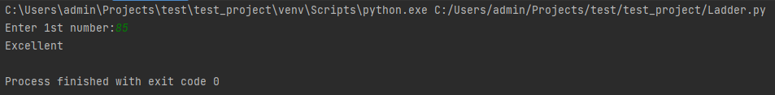

* Nested statement :-  
    
   a = int(input("Enter 1st number: "))

if (a > 10):  
 print("Above ten")  
 if (a > 20):  
 print("and also above 20")  
 else:  
 print("But not above 20")  
 else:  
 print("not above 10")

* Output :-

